Full Stack Project Report

**On**

**Amozon (Amazon Clone)**

**Submitted By-**

**Md Rashid**

**(181500381)**

**Pulkit Ranjan**

**(181500519)**

**Suraj Garg**

**(181500735)**

**Ishank Jain**

**(181500281)**

Department of Computer Engineering & Applications

**Institute of Engineering & Technology**



**GLA University**

**Mathura- 281406, INDIA**

**2020**

**Declaration**

We hereby declare that the work which is being presented in the B.Tech. Project **“Amozon”**, in partial fulfilment of the requirements for the award ofthe ***Bachelor of Technology*** in Computer Science and Engineering and submitted to the Department of Computer Engineering and Applications of GLA University, Mathura, is an authentic record of our own work carried under the supervision of **Mr. Pankaj Kapoor, Assistant Professor.**

The contents of this project report, in full or in parts, have not been submitted to any other Institute or University for the award of any degree.

Sign: __Md.Rashid__ Sign: __Suraj Garg__

Name of Candidate: Md. Rashid Name of Candidate: Suraj Garg

University Roll No.: 181500381 University Roll No.: 181500735

Sign: _Pulkit Ranjan__ Sign: _Ishank Jain__

Name of Candidate: Pulkit Ranjan Name of Candidate: Ishank Jain

University Roll No.: 181500519 University Roll No.: 181500281

**Certificate**

This is to certify that the project entitled “Amozon” has been developed by B.tech students of GLA University, Mathura towards partial fulfilment of the requirements for the award of the degree of Bachelor of Computer Science is a genuine record of the work carried out by Him/her under My Supervision and Guidance and the project report is the original work of student. They have worked on the project Airline Reservation System. They have used CSS, HTML, JAVASCRIPT, ReactJs, NodeJs, Firebase for the project. Their work is satisfactory. I wish Them all the best for his bright future.

Date: 10/05/2021

Signature of Guide

Place:

Pankaj Kapoor(Assistant Professor)

**Abstract**

This project is a web based shopping system for an existing shop. The project objective is to deliver the online shopping application into android platform. This project is an attempt to provide the advantages of online shopping to customers of a real shop. It helps buying the products in the shop anywhere through internet by using an android device. Thus the customer will get the service of online shopping and home delivery from his favourite shop. This system can be implemented to any shop in the locality or to multinational branded shops having retail outlet chains. If shops are providing an online portal where their customers can enjoy easy shopping from anywhere, the shops won’t be losing any more customers to the trending online shops such as Amazon. Since the application is available in the Smartphone it is easily accessible and always available.

Acknowledgement

It gives me a great sense of pleasure to present the synopsis of the Full Stack Project (Building a Amazon clone ) undertaken during B.Tech. IIIrd Year, this project itself is going to be acknwledgement to the inspiration, drive and technical assistance will be contributed by me.

I owe special debt of gratitude to Mr. Pankaj Kapoor(Assistant Professor, Department of Computer Science and Engineering) for providing me with an encouraging platform to develop this project which thus helped me in shaping my abilities towards a constructive goal and for his constant support and guidance to my work. His sincerity, Thoroughness and perseverance are being a constant source of inspiration for me. He had showered me with all his extensively experienced ideas and insightful comments at different stages of the project & also taught me about the latest industry-oriented technologies.

Md Rashid (181500381)

Pulkit Ranjan (181500519)

Suraj Garg (181500735)

Ishank Jain(181500281)

Contents

|  |  |
| --- | --- |
| Cover and Title  Abstract | I |
| Certificate | ii |
| Abstract | iii |
| Declaration | iv |
| Acknowledgement | v |
| Table of Contents | vi |
|  |  |
| 1. **Introduction** | **1** |
| 1. **Software Requirement Analysis** | **6** |
| 1. **Software Design** | **14** |
| 1. **Testing** | **17** |
| 1. **Implementation and User Interface** | **18** |
| **6. Limitations and Conclusions** | **28** |
| **7. References** | **29** |
|  |  |

Introduction

**About Organisation:**

GLA University is approved and recognized by University Grants Commission, NCTE and Pharmacy Council of India. It has been accredited by the National Assessment and Accreditation Council with ‘A’ Grade. GLA University ranked 1 among all universities present in Mathura, birth place of Lord Krishna.

**About Project:**

The central concept of the application is to allow the customer to shop virtually using the Internet and allow customers to buy the items and articles of their desire from the store. The information pertaining to the products are stores on an Firebase at the server side (store). The Server process the customers and the items are shipped to the address submitted by them. The application was designed into two modules first is for the customers who wish to buy the articles. Second is for the storekeepers who maintains and updates the information pertaining to the articles and those of the customers. The end user of this product is a departmental store where the application is hosted on the web and the administrator maintains the database. The application which is deployed at the customer database, the details of the items are brought forward from the database for the customer view based on the selection through the menu and the database of all the products are updated at the end of each transaction. Data entry into the application can be done through various screens designed for various levels of users. Once the authorized personnel feed the relevant data into the system, several reports could be generated as per the security.

**Motivation and Objective:**

The main motivation behind this project is eagerness to learn basics of Web Development because I was interested in building of websites. I have always wondered how tiny bits of codes can do all things like this and I always wanted to develop a website.

The Objective was to gain knowledge about web development and learn all technologies related to it like HTML, CSS, JavaScript, ReactJs, and Firebase and also learn about some inbuilt libraries of CSS. so that I can develop a working website and show everyone that I have learnt something.

As technology advances internet is becoming ever popular. Website has become an essential part. Nowadays it is now very unusual for a business not to have some sort of presence online. With improved connectivity and the advances in Smartphone technologies most people now use the internet to source information, and having your business available to fulfil these information searches is key to driving more footfalls through your door.

A website gives you a controlled way to portray an image of your business as you would like it, giving your customers an idea of the atmosphere and offering before even stepping a foot inside.

**Problem Description**

**Problem Statement:**

This projects aims to develop an online shopping for customers with the goal so that it is very easy to shop your loved things from a extensive number of online shopping sites available on the web. With the help of this you can carry out an online shopping from your home. Here is no compelling reason to go to the crowed stores or shopping centers during festival seasons. You simply require a PC or a laptop and one important payment sending option to shop online. To get to this online shopping system all the customers will need to have a email and password to login and proceed your shopping . The login credentials for an online shopping system are under high security and nobody will have the capacity to crack it easily. Upon successful login the customers can purchase a wide range of things such as mobiles, books, apparel, jeweler, infant care, gifts, tools, etc. can be dispatched using online shopping system. Not just these, you can also purchase from outside nations by few clicks on your mouse. And of course you will get your requested ordered items at your door step. It is simple. You will pick your favorite items from variety of online shopping sites looking at cost and quality. No need to go physical shops with this you will have more time to spend with your family.It Just need a computer and a payment making options like net banking, credit card, debit card or paypal. Almost a wide range of things can be brought through online shopping system. You can purchase goods from foreign places from your bedroom and you will get your goods at your home.It is extremely secure. Customer service is accessible.

**Proposed System:**

The Proposed system ensures the complete freedom for users, where user at his own system can logon to this website and can book their orders. Our proposed system allows only registered users to book the orders, view and cancel their orders. To debug the existing system, remove procedures those cause data redundancy, make navigational sequence proper to build strong password mechanism.

Advantages:

* User friendliness provided in the application with various controls.
* The system makes the overall project management much easier and flexible.
* It provides high level of security with different level of authentication.

Requirement Analysis

**Tools Required:**

For developing my project first, we have to analyse what are the different tools required for developing this project.

**Hardware Required:**

1. A Personal Computer with any Operating System and Internet Connection.
2. With any Processor
3. RAM of computer must be 128 **MB**.
4. Free Disk space of hard disk must be around 20GB.

**Software Requirements:**

1. **Web Browser:** A web browser to run codes and debug and view my work development and use its inspecting feature and console window.
2. **VS Code:** It’s a platform where I can write my code and maintain my Files.
3. **Git and Git-Hub:** This was required for hosting my website on internet.

**Technologies Used:**

1. **HTML5:** HTML5 is a mark-up language used for structuring and presenting content on the World Wide Web. It is the fifth and latest major version of HTML that is a World Wide Web Consortium recommendation.

* HTML is the standard mark-up language for creating Web pages.
* HTML describes the structure of a Web page.
* HTML consists of a series of elements.
* HTML elements tell the browser how to display the content.

1. **CSS3:** Cascading Style Sheets (CSS) is a style sheet language used for describing the look and formatting of a document written in a mark-up language.

* CSS describes how HTML elements are to be displayed on screen, paper, or in other media
* CSS saves a lot of work. It can control the layout of multiple web pages all at once.

1. **JavaScript:**

JavaScript often abbreviated as JS, is a programming language that conforms to the ECMAScript specification. JavaScript is high-level, often just-in-time compiled, and multi-paradigm. It has curly-bracket syntax, dynamic typing, prototype-based object-orientation, and first-class functions.Alongside HTML and CSS, JavaScript is one of the core technologies of the World Wide Web. JavaScript enables interactive web pages and is an essential part of web applications. The vast majority of websites use it for client-side page behaviour, and all major web browsers have a dedicated JavaScript engine to execute it.

1. **ReactJS:**

React (also known as React.js or ReactJS) is an open-source, front end, JavaScript library for building user interfaces or UI components. It is maintained by Facebook and a community of individual developers and companies. React can be used as a base in the development of single-page or mobile applications. However, React is only concerned with state management and rendering that state to the DOM, so creating React applications usually requires the use of additional libraries for routing, as well as certain client-side functionality.

1. **NPM:**

* npm, Inc. is a company founded in 2014, and was acquired by GitHub in 2020. npm is a critical part of the JavaScript community and helps support one of the largest developer ecosystems in the world. npm is lots of things.
* npm is the package manager for Node.js. It was created in 2009 as an open source project to help JavaScript developers easily share packaged modules of code.
* The npm Registry is a public collection of packages of open-source code for Node.js, front-end web apps, mobile apps, robots, routers, and countless other needs of the JavaScript community.
* npm is the command line client that allows developers to install and publish those packages.

**Modules: Projects has 2 modules.**

**Homepage :-**

* Contains name and logo of Amazon
* Contains picture with General Introduction to Company.
* Contains quick navigation to special pages.

**Booking Page:**

* Contains Booking page with information .
* Contains Review page.
* Contains Payment Page

**SRS**

1. **Introduction**

* Purpose: The main purpose for preparing for preparing this document is to give a general insight into the analysis and requirements of the existing system or situation and for determining the operation characteristics of the system.
* Scope: This document plays a vital role in the development life cycle (SDLC) and it describes the complete requirement of the system. It is meant for use by the developers and will be the basic during testing phase. Any changes made to the requirements in the future will have to go through formal change approval process.

1. **General Description** –

A description about the features of the system.

Product perspective:

This project is mainly towards persons who are willing shop online and book their items online.

* Product functions:

Homepage, Booking, Cart, Payment,Orders.

* User characteristics:

In here, the passenger can visit the website and understand the information about the reservation site which is written in English language and he/she can interact easily with the website.

* General constraints
* The program will be written in HTML, CSS and JavaScript , ReactJs, Firebase.
* The system will mainly running on the URL : **https://github.com/jainishank733/amazon_clone_mernstack_app**
* Assumption & Dependencies:
* Every customer has a mobile phone/tablet/pc.
* Every Passenger is able to read about Aeroplanes and book accordingly.

1. Specific Requirements –

This document is generated as output of requirement analysis. The requirement analysis involves obtaining a clear and through understanding of the product to be developed.

Each requirement in this section should be:

* Correct
* Traceable (both forward and backward to prior/future artefacts)
* Unambiguous
* Verifiable (i.e., testable)
* Prioritized (with respect to importance and/or stability)
* Complete
* Consistent

It has been required that every form’s interface should be user friendly and simple to use.

Designing:

**Wireframe diagram:**

**Homepage layout**

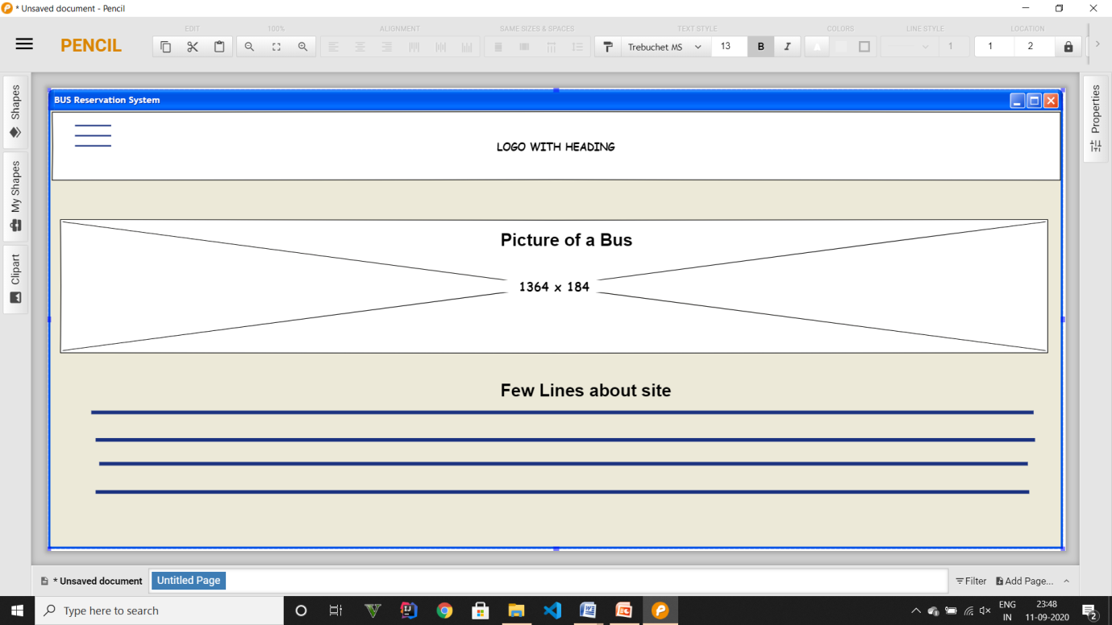

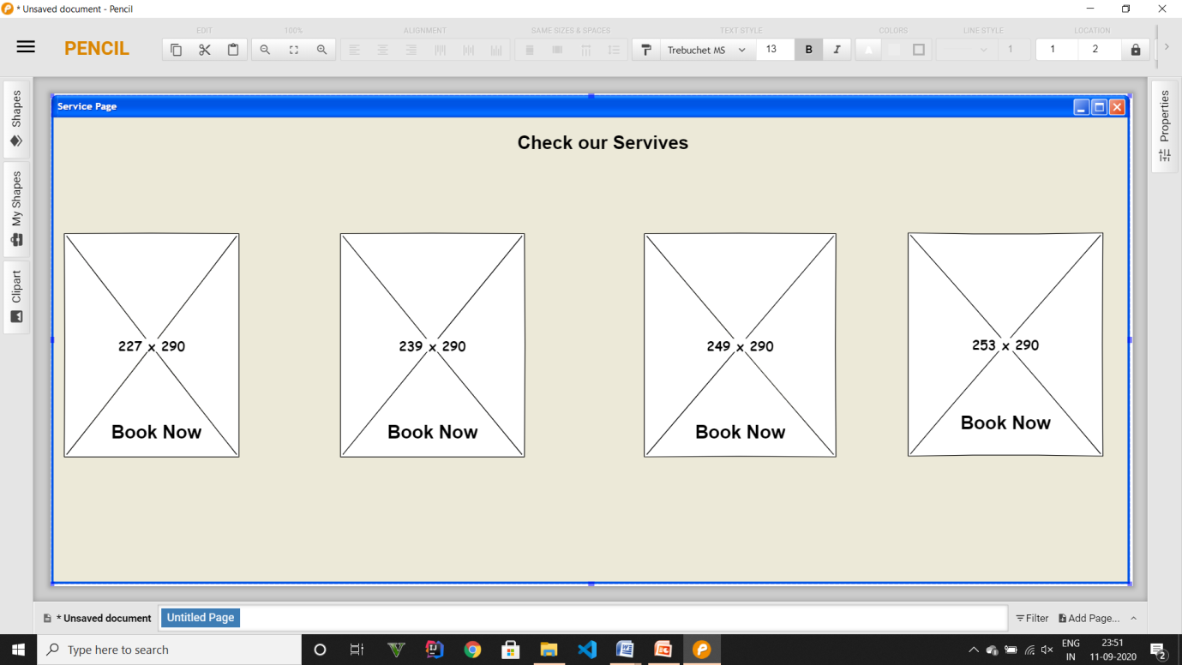

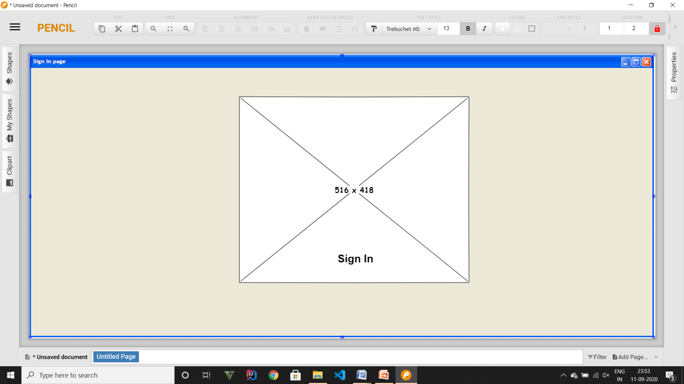

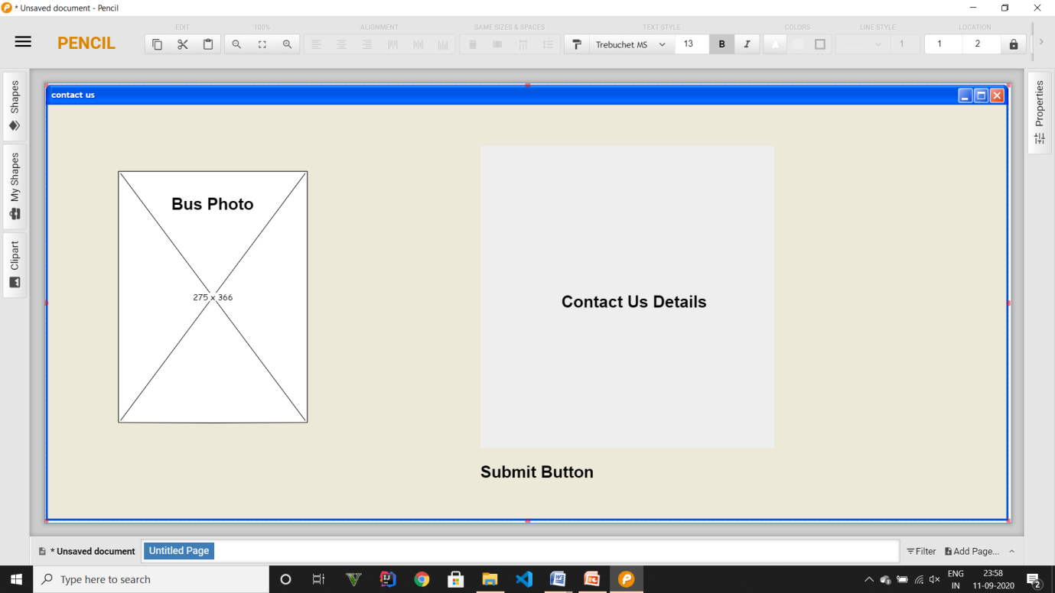

**Testing**

Software testing is a critical element of software quality assurance and represents the ultimate review of specification design and coding. In fact, testing is the one step in the software engineering process that could be viewed as destructive rather than constructive.

A strategy for software testing integrates software test case design methods into a well-planned series of steps that result in the successful construction of software. Testing is the set of activities that can be planned in advance and conducted systematically. The underlying motivation of program testing is to affirm software quality with methods that can economically and effectively apply to both strategic to both large and small-scale systems.

**Strategic Approach to Software Testing**

The software engineering process can be viewed as a spiral. Initially, system engineering defines the role of software and leads to software requirement analysis where the information domain, functions, behaviour, performance, constraints and validation criteria for software are established. Moving inward along the spiral, we come to design and finally to coding. To develop computer software, we spiral in along streamlines that decreases the level of abstraction on each turn.

|  |  |  |  |  |
| --- | --- | --- | --- | --- |
| **Test id** | **Test case title** | **Description** | **Expected Outcome** | **Result** |
| **1.** | Desktop View | All the navigation links are on the header part of the website. | All the contents are arranged and easily visible (range 1300px – 900px of screen) according to the wireframe. | Success |
| **2.** | Mobile View | Sidebar comes in front and focus, | All the contents are arranged and easily visible (range 600px – 300px of screen) | Success |
| **3.** | Entering login details | All the navigation links are on the header part of the website. | All the entries are successfully entered. | Success |
| **4.** | Adding items to cart | Adding of item in cart | Item added | Success |
| **5.** | Checking out | Checking out by paying | Checkout  successfully | Success |
|  |  |  |  |  |
|  |  |  |  |  |
|  |  |  |  |  |
|  |  |  |  |  |
|  |  |  |  |  |

**Implementation and User Interface**

**User Interface – Here are some Screenshots of the project**

**Home Page**

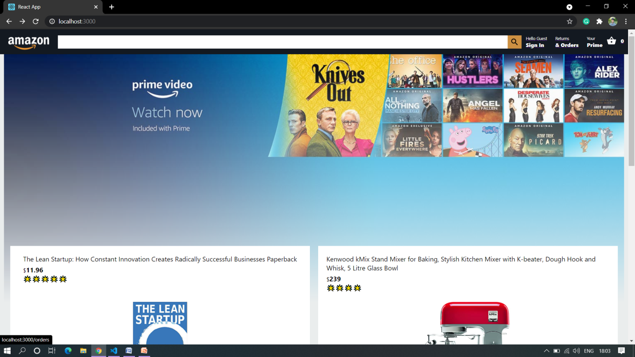

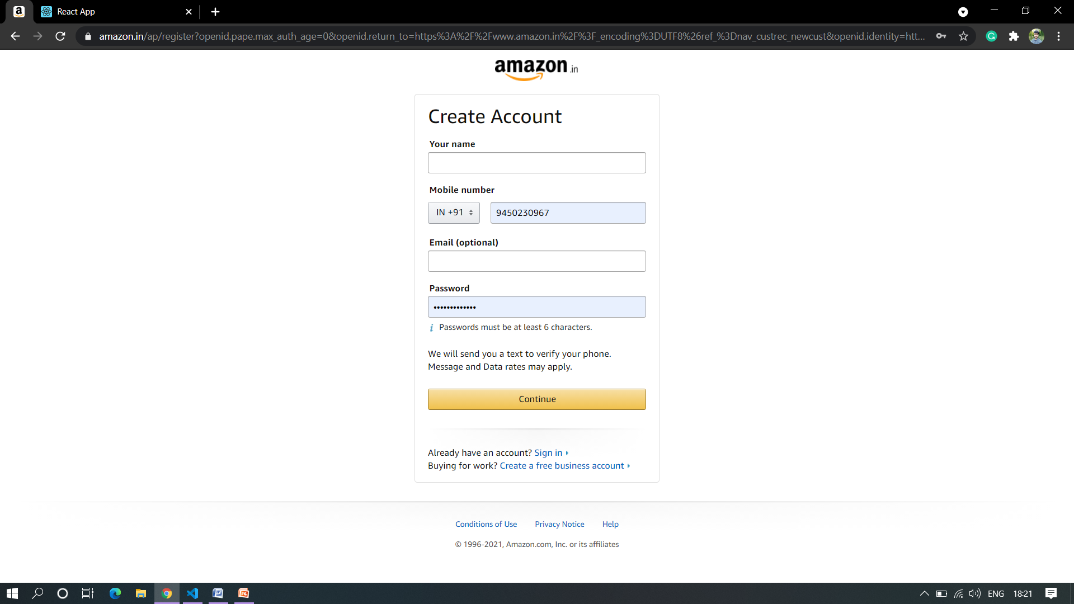

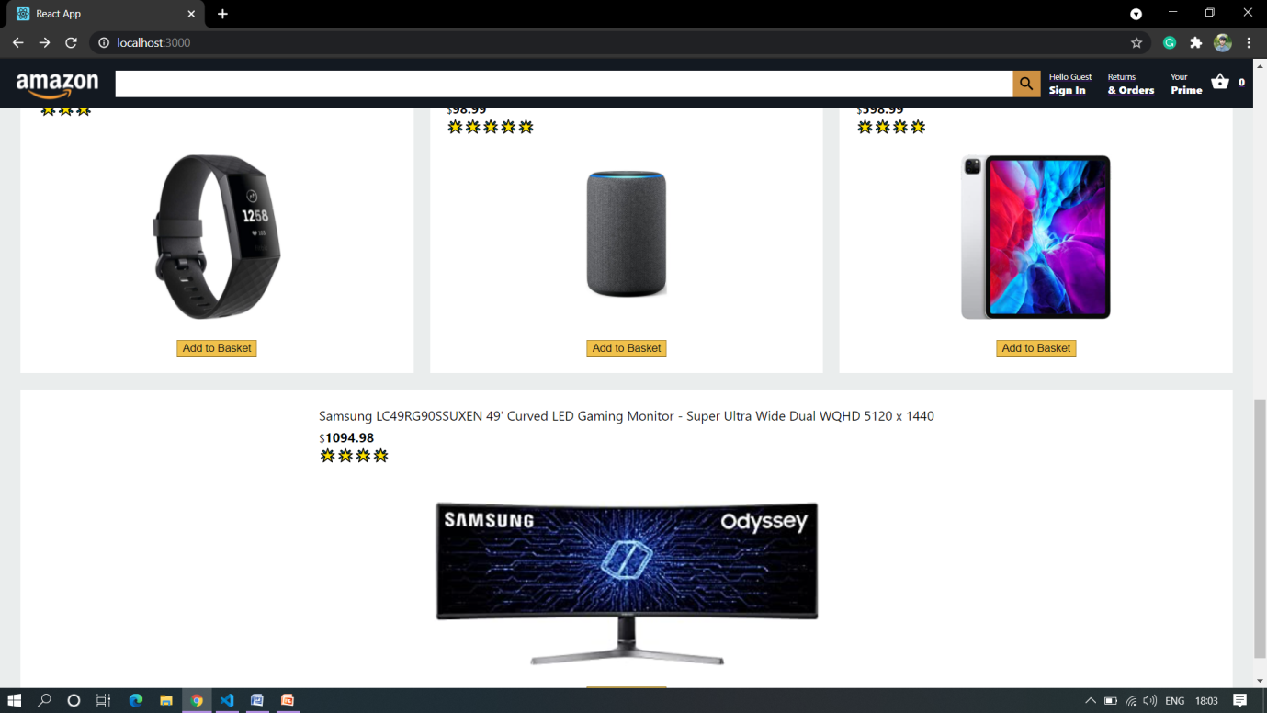

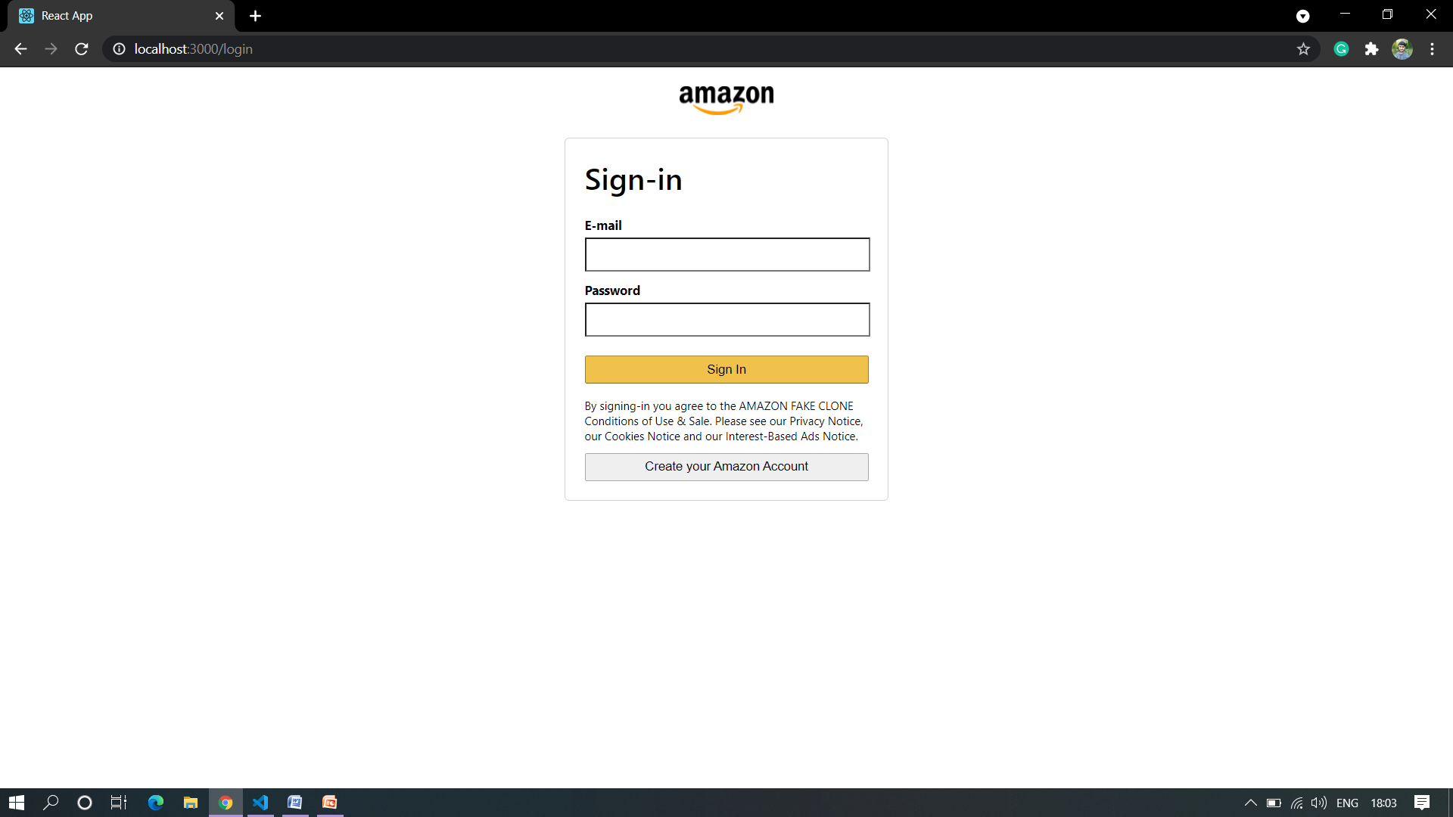

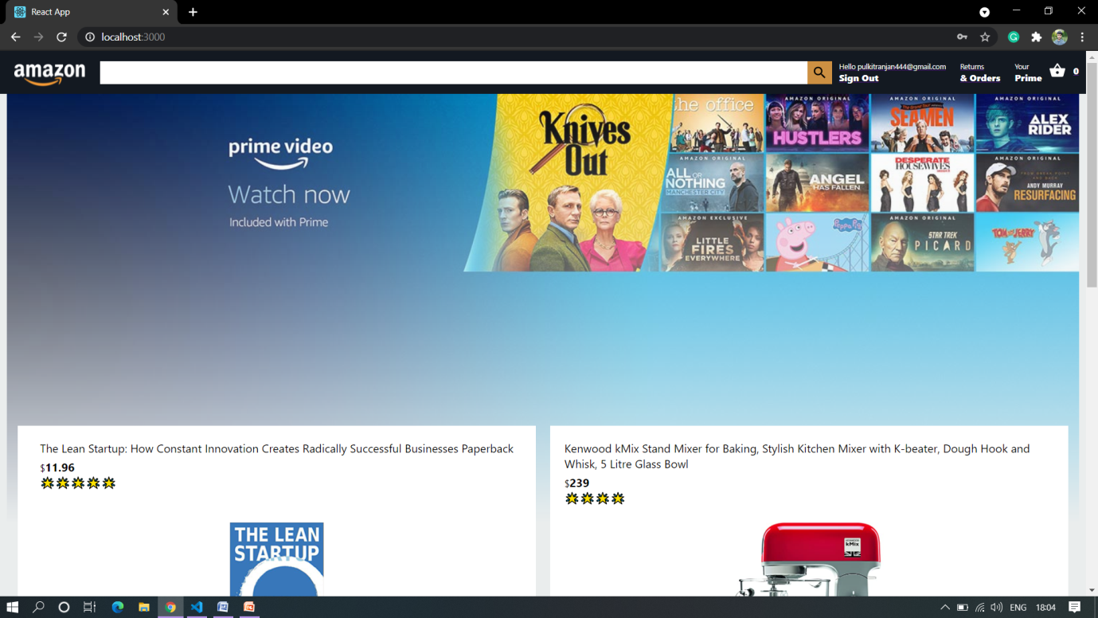

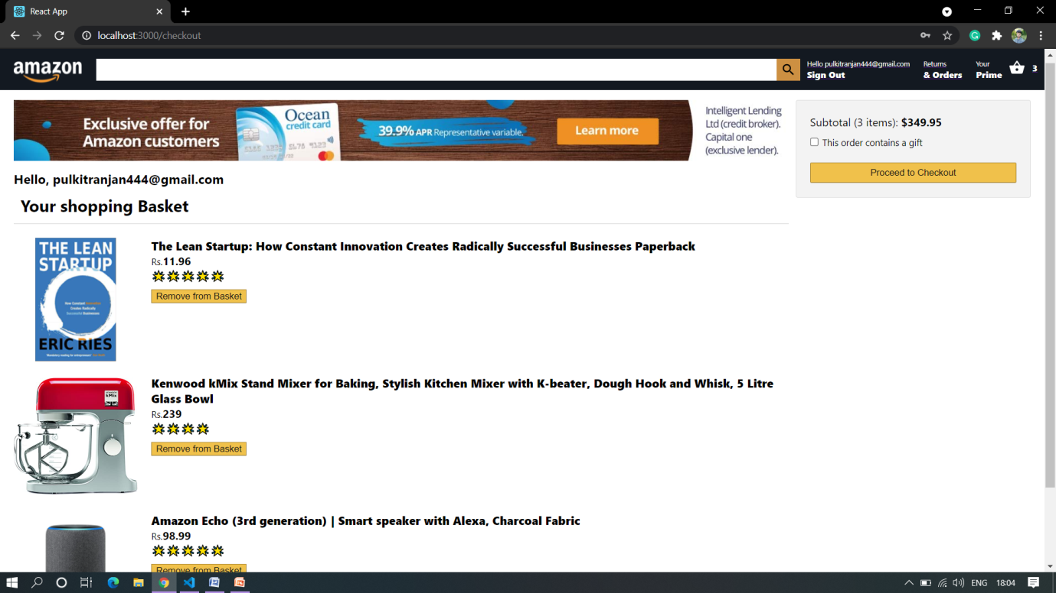

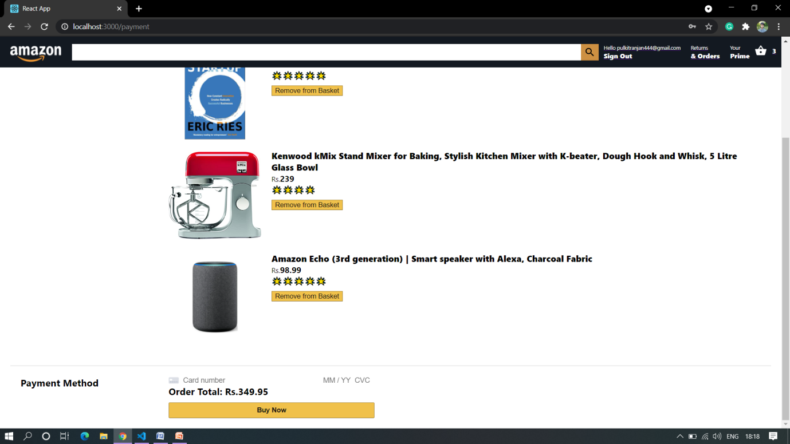

Conclusion:

After coding and building this Amazon Clone Website, I get to learn about different processes related to the development of a website page. The first getting input from the passenger regarding what he wants to get from website then showing him different design and creating design and after approval of it the best part is coding the website it was really fruitful experience and I get to learn many things.

Limitations:

This system can be implemented to any shop in the locality or to multinational branded shops having retail outlet chains. The system recommends a facility to accept the orders 24*7 and a home delivery system which can make customers happy. If shops are providing an online portal where their customers can enjoy easy shopping from anywhere, the shops won’t be losing any more customers to the trending online shops such as Amazon. Since the application is available as Website it is easily accessible and always available.

**Reference and Bibliography –**

**Google –** [**www.google.com**](http://www.google.com)

**YouTube –https://www.youtube.com/**

**Beta labs -http://beta-labs.in/**

